**Assignment 2 -- NORMALIZATION**

Total points: 50

**This assignment should be completed individually. Save your completed assignment as a word document or .pdf file and submit via eLearning.**

The travel office at Pilot Training College maintains information about flights, pilots, and passengers. You have been given the following assumptions:

* A flight has a unique flight number, a passenger has a unique name, a pilot has a unique name
* A flight is handled by one airline
* A flight can have multiple passengers, a passenger can be on multiple flights
* A flight has one pilot, a pilot can operate multiple flights
* A flight is always handled by exactly one airplane

You have been given the following relation:

Flight (flightnumber, flighttime, airelinename, passengername, pass_gender, pass_dateofbirth, pilotname, pil_gender, pil_dateofbirth, departure_city, arrival_city, planeid, plane_type, seats).

1. ***Answer the following questions:***
2. What is the PK for this relation in its current state? (4 pts)
   1. **Primary key**
      1. flightnumber, passengername
   2. **Dependency**
      1. flightnumber, passengername ­-> flighttime, airlinename, pass_gender, pass_dateofbirth, pilotname, pil_gender, pil_dateofbirth, departure_city, arrival_city, planeid, plane_type, seats
3. What Normal Form is the current state of this relation? (4 pts)
   1. **1NF**
4. ***Perform the following Normalization steps:***
5. List the partial and transitive dependencies. (6 pts)
   1. **Partial**
      1. flightnumber ­-> planeid, pilotname, airlinename, flighttime, departure_city, arrival_city, pil_dateofbirth, pil_gender, plane_type, seats
      2. passengername -> pass_gender, pass_dateofbirth
   2. **Transitive**
      1. pil_name -> pil_gender, pil_dateofbirth
      2. planeid -> plane_type, seats

***EXAMPLE:***

**Partial Dependencies**

No Partial Dependencies

**Transitive Dependencies**

JOB_CLASS 🡪 emp_base_salary

1. Convert the relation to 3NF. (Hint: You might have to create a few new attributes to make sure that the relations contain attributes that meet proper design criteria; that is, make sure there are no composite or multivalued attributes and that the naming conventions are met.) Write the corresponding relational schemas for each new relation. Identify each primary key and each foreign key. (20 pts)
   1. **Relational Schema:**
      1. FLIGHT(**FLIGHT_NUM**, FLIGHT_TIME, PLANE_ID, PILOT_ID, AIRLINE_NAME, DEPARTURE_CITY, ARRIVAL_CITY)
      2. PASSENGER(**PASS_ID**, PASS_FNAME, PASS_MI, PASS_LNAME, PASS_GENDER, PASS_DOB)
      3. PILOT(**PIL_ID**, PIL_FNAME, PIL_MI, PIL_LNAME, PIL_GENDER, PIL_DOB)
      4. PLANE(**PLANE_ID**, PLANE_TYPE, PLANE_NUM_SEATS)
      5. FLIGHT DIRECTORY(**FLIGHT_NUM** (FK), **PASS_ID** (FK))
         1. Note: Since the relationship between FLIGHT and PASSENGER is M:N, I made a composite entity (FLIGHT DIRECTORY) that has both FLIGHT_NUM and PASS_ID acting as primary and foreign keys in this entity. This entity does not have any other attributes.

***EXAMPLE:***

**Relational Schema:**

EMP(**EMP_NUM**, EMP_NAME, EDU_CODE)

1. Draw an ERD with the new set of relations. (16 pts)

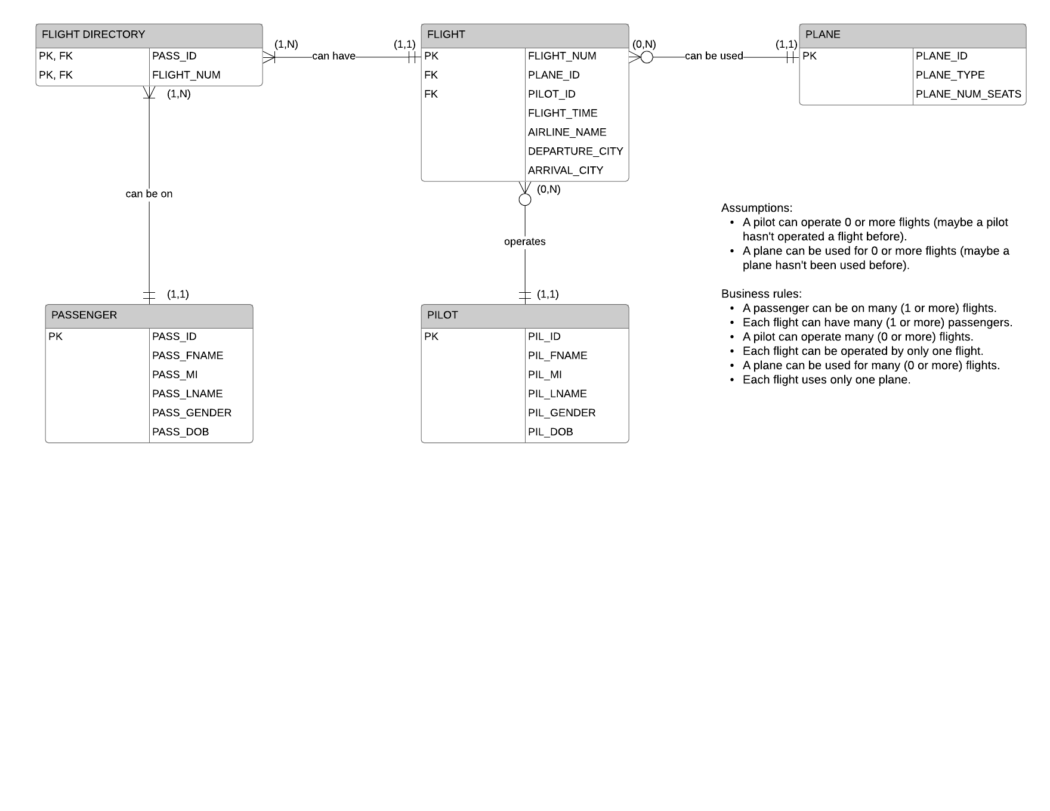

* 1. **Link to ERD:** [**https://www.lucidchart.com/invitations/accept/cb13060e-0f7e-441e-adcc-3008856f7125**](https://www.lucidchart.com/invitations/accept/cb13060e-0f7e-441e-adcc-3008856f7125)
  2. **There will also be an attachment on eLearning containing the PDF version of the ERD.**

**SAMPLE DATA SET**

|  |  |  |  |  |  |  |  |  |  |  |  |  |  |
| --- | --- | --- | --- | --- | --- | --- | --- | --- | --- | --- | --- | --- | --- |
| **Flightnumber** | **Passengername** | **Flighttime** | **Airlinename** | **Pass_gender** | **Pass_dob** | **Pilotname** | **Pil_gender** | **planetype** | **Seats** | **Pil_dob** | **Departure_city** | **Arriaval_city** | **Planeid** |
| 38249 | Brown, Thomas | 10 am | SWA | M | 3/16/87 | Lexor | M | 32B | 50 | 9/30/63 | Arlington | Waco | 25 |
| 38249 | Green, Sally | 10 am | SWA | F | 4/12/82 | Lexor | M | 32B | 50 | 9/30/63 | Arlington | Waco | 25 |
| 82458 | Wiley, Dennis | 9 pm | PPX | M | 5/6/70 | Lexor | M | 96A | 30 | 9/30/63 | Dallas | San Antonio | 15 |
| 82453 | Green, Sally | 9 pm | PPX | F | 4/12/82 | Lexor | M | 96A | 30 | 9/30/63 | Dallas | San Antonio | 15 |
| 92453 | Smith, John | 10:30 am | CCA | M | 6/25/85 | Curry | F | MD11 | 10 | 10/5/70 | Arlington | Houston | 35 |
| 92453 | Doby, Mary | 10:30 am | CCA | F | 8/8/87 | Curry | F | MD11 | 10 | 10/5/70 | Arlington | Houston | 35 |